Monday, October 24, 2022

10:13 AM

VPC Amazon Virtual Private Cloud

It's basically one or more data centers.

Public Subnets

Private Subnets  
  
  
**Select** VPC we have one availability VPC for free

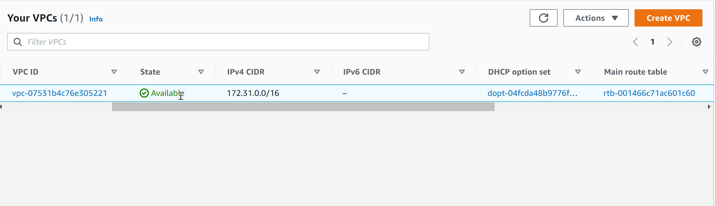

Subnets

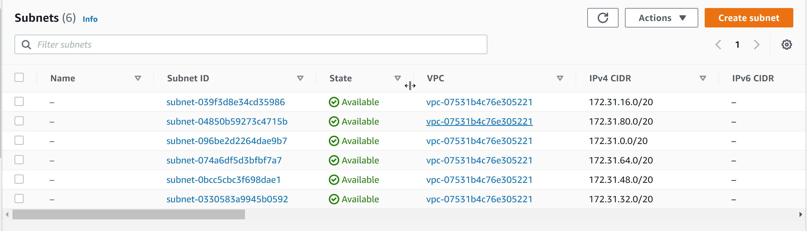

Installing the AWS CLI version 2.  
  
https://docs.aws.amazon.com/cli/latest/userguide/getting-started-install.html

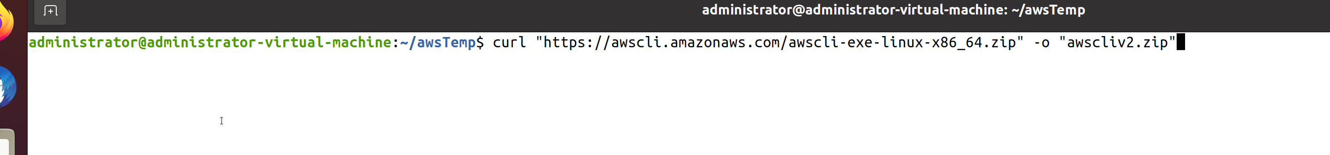

Unzip the file and run the command.

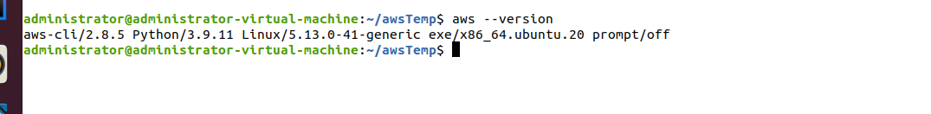

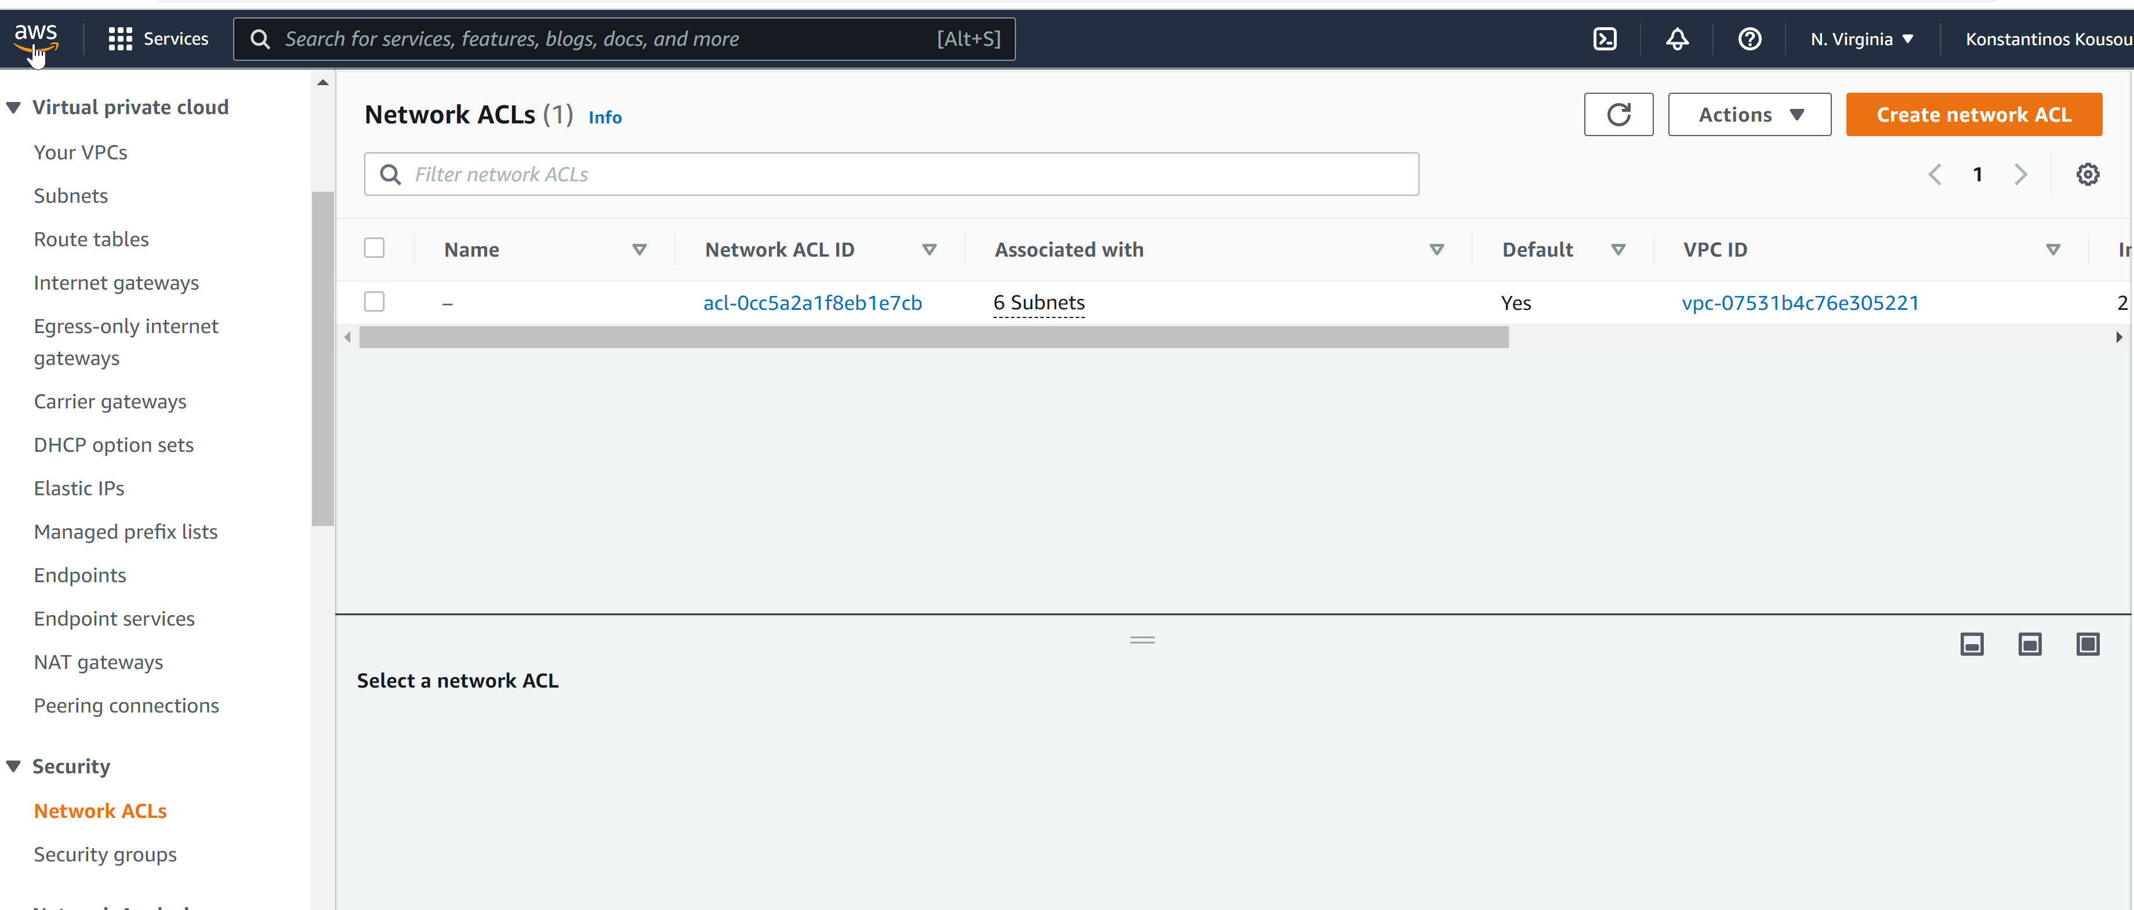

Communications are allowed only inside the Security Group that are all instances.